Write a C++ program to demonstrate user-defined functions and function calls as illustrated below.
main function
functionA
functionB

The functions are described below in “pseudo code.”

functionA (local variable n)
n = n + 1
display the number of times functionA has been called
display Memory Map for functionA
variable n address and value
return the value of n

functionB (local variable n)
n = n + 1
display the number of times functionB has been called
display Memory Map for functionB
variable n address and value
return the value of n

main function:
declare: variable a = the number of times functionA is called
declare: variable b = the number of times functionB is called
menu for main
display Memory Map for function Main
variable a address and value
variable b address and value
1. call functionA, send the value of a
assign the return value to a
2. call functionB, send the value of b
assign the return value to b
3. exit

Document the exercise in a Word document.

Input
// ECE 2305 - Tutorial 18
// User-define Functions and Functions Calls
#include<iostream>
using namespace std;
int functionA(int n)
{ n = n + 1;
cout << "Function A has been called " << n << " times." << endl;
cout << "Memory Map for Function A" << endl;
cout << "Name \tAddress \tValue" << endl;
cout << "n \t" << &n << "\t" << n << endl;
return n;
}
int functionB(int n)
{
n = n + 1;
cout << "Function B has been called " << n << " times." << endl;
cout << "Memory Map for Function B" << endl;
cout << "Name \tAddress \tValue" << endl;
cout << "n \t" << &n << "\t" << n << endl;
return n;
}
int main()
{
int a = 0;
int b = 0;
int choice = 0;
do
{
system("cls");

cout << "ECE 2305 - Tutorial 18" << endl;
cout << "User-defined Functions and Function Calls" << endl;
cout << endl;

cout << "Memory Map for Function Main" << endl;
cout << "Name \tAddress \tValue" << endl;
cout << "a \t" << &a << "\t" << a << endl;
cout << "b \t" << &b << "\t" << b << endl;
cout << endl;

cout << "Main Menu." << endl;
cout << "1. Call Function A." << endl;
cout << "2. Call Function B." << endl;
cout << "3. End." << endl;
cout << endl;
cout << "Please make selection: ";
cin >> choice;
switch (choice)
{
case 1:
cout << "The user chose Function A." << endl;
cout << endl;
a = functionA(a);
cout << endl;
system("pause");
break;
case 2:
cout << "The user chose Function B." << endl;
cout << endl;
b = functionB(b);
cout << endl;
system("pause");
break;
case 3:
cout << "The user chose to end." << endl;
cout << endl;
system("pause");
break;
default:
cout << "Please make a proper choice." << endl;
system("pause");
}
} while (choice != 3);
return 0;
}
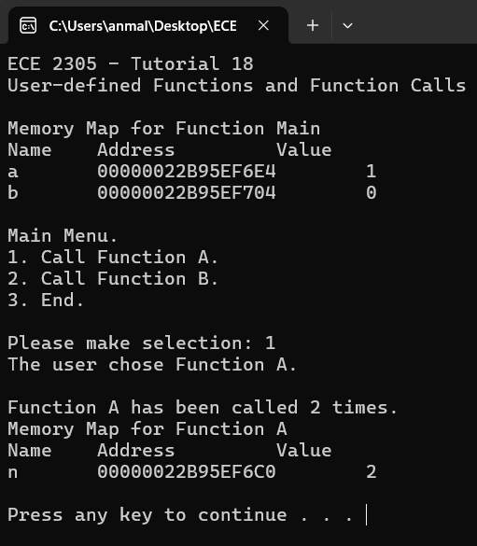
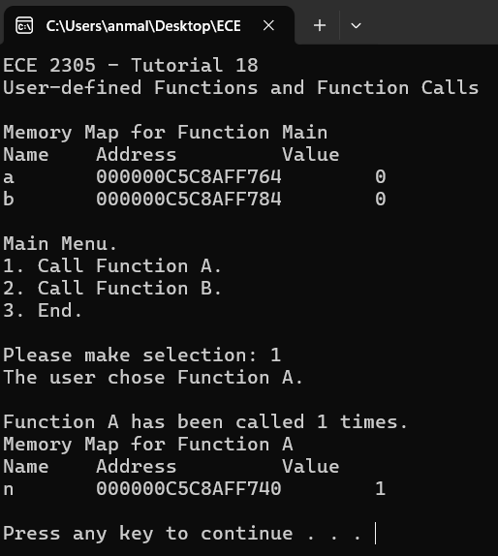
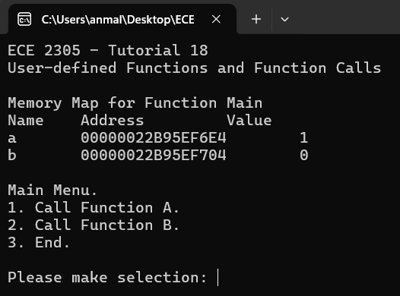
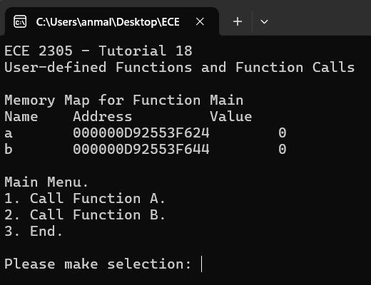
Output

